Artificial Propagation of Plants
Aditya
Science
26/11/2012
Application:
Plants have the basic ability to reproduce through seeds, spores or from reproductive growths such as rhizomes or tubers. However, there are issues that are encountered when the plant is reproducing naturally. Some plants take longer than the required time to grow, this is considered a problem because the fruit production rate will be delayed. Another issue with plants is how some species are severely endangered and are about to go extinct. The largest issue though is how certain plants can’t produce a lot of seeds or even produce a viable seed. Therefore, one solution is artificial propagation. Artificial propagation is the process of growing countless plants from one plant by man-made methods. Another to say it is the unnatural method in growing plants.
There are countless methods to artificial propagation, the three most common methods are cuttings, layering and grafting:
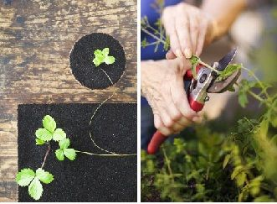
- Cutting is a method where a small part of plant is removed by making a cut with a sharp knife. This small part is also referred as a ‘cutting’. A cutting may be a part of a stem, root or even a leaf. When a ‘cutting’ is being made, carefulness is necessary to make sure that some buds are on it.

When a ‘cutting’ with some buds on it is already obtained, the lower part of it is then buried in the moist soil. After a few days, the cutting should develop roots, shoot and finally grow into a new plant. The new plant produced from a cutting will be exactly identical to the parent or original plant.
Cuttings can also be stated as forms of asexual reproduction in plants. There are countless plants grown by the means of cutting such as roses, grapes, sugarcane, bananas, and cactus, etc. For example, rose plants are propagated by obtaining a cutting from their stems. The lower part of the cutting is then buried in moist soil. After a few days, it grows into a new rose plant.
- Layering is the second method in artificial propagation. The layering method is when the branch of a plant is pulled towards the ground and a part of it is covered with moist soil. This leaves a tip of the branch exposed above the ground. After a period of time, new roots will grow from the part of the branch which was buried within the soil. The branch connecting the new plant with the parent plant is then cut off. When this occurs, the new plant can grow on their own into becoming mature plants.
There is also the term ‘natural layering’. Natural layering occurs when the plants which are propagated by the layering method, form runners. Runners are horizontally soft stems stretching above the ground. When these runners touch the ground, new plants will grow there. Therefore more plants will grow naturally.
Many plants are propagated by the layering method such as jasmine, strawberry, raspberry, lemon, guava, hibiscus, and many other plants.
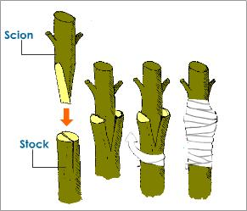
- The last method is grafting. Grafting is a method where the stems of two different plants are cut off. From these two plants, one will have roots and the other without. The two stems are then joined together and they will grow as one plant. This new plant will have the features of both original plants.

The stem of the plant that has roots is called stock. Stock is the lower part of the plant. The other plant without roots is called scion. Scion is then the upper part of the plant. Scion may have leaves but no roots. In grafting, the stock and the scion is removed by making a slanted cut. When the scion is placed over the stock, a piece of cloth and a polythene sheet is required to bind them together. Especially the polythene sheet, its functions is to prevent the penetration of bacteria and infections while the stock and scion is growing together.
Effectiveness:
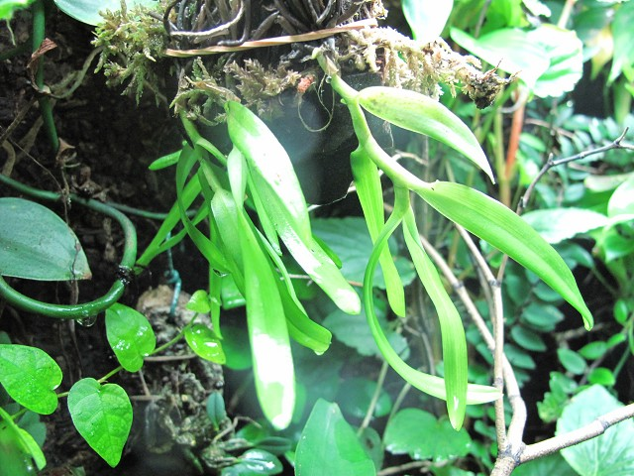
Artificial propagation is a very effective method to solve the stated issues above. Artificial propagation serves as a reliable solution to solve the issues in natural plant growth. Some plants in the world such as bananas and figs don’t have the ability to produce viable seeds. Therefore artificial propagation is used to reproduce these plants. This way the production of fruit will grow rapidly and the plant species won’t go extinct. Another advantage in using artificial propagation is how it’s a faster and cheaper method compared to growing with seeds. This is a massive benefit because it will not only increase the amount of plants, it will also improve the people’s welfare. When a plant is about to be propagated, the grower will have the privilege in deciding the desirable characteristics of the plant. The grower can grow what is needed.
Despite the countless benefits in using artificial propagation, there is no such thing as a perfect method. Therefore, this means that there are still disadvantages in using artificial propagation. One disadvantage is that even though the new plant will be identical with the parent plant, the plants will gradually loose their vigor because there is no generic variation. Not that to mention that the new plants are more prone to diseases which can result in the destruction of an entire crop. The last disadvantage is the overcrowding of plants, the plants will then have a lack of nutrients. This isn’t good because the new plant will not grow perfectly.
These are the advantages and disadvantages of artificial propagation. Even though the disadvantages sound severe, artificial propagation still is very useful. The advantages have provided many benefits to this world.

Factors:
Environmental
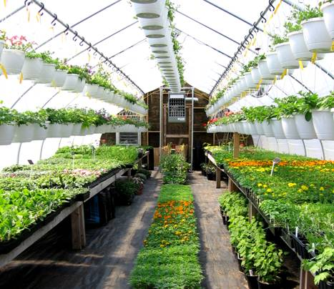
Artificial propagation is the unnatural method in reproducing plants. Therefore, it definitely has relevance with the environment because plants form the foundation of the environment. When new plants are reproduced from the parent plant, this improves the environment because there will be more plants in the environment. Having more plants in the environment provides various benefits. One massive benefit is having more oxygen, plants have the natural function of taking in carbon dioxide and releasing oxygen. This improves the lives of most living creatures including us humans. Also, with more plants there will more fruits in the environment. With more fruits in the environment, living creatures like humans and insects will be able to survive. They won’t go extinct and the environment will remain stable.
Social
Artificial propagation also affects us humans, it benefits the social world. As stated in the environment section, the more plants growing, the more oxygen is released. Oxygen is a very crucial element in this world. Without oxygen, humans will not be able to live. Oxygen isn’t the only thing that is produced, using artificial propagation will also increase the amount of fruit. Since the plants grown by artificial propagation grow faster than the ones using seeds, the fruits will also be obtained faster. This way the people will have a better supply of food. Not to mention how the grower of the new plant can grow the plant with the desired characteristics. The grower can grow what is required. This proves that artificial propagation really aids the people’s welfare.
Economic
Eventhough artificial propagation is about an alternative method in reproducing plants, it can also be linked with economics. Generally, when plants are grown naturally, the fruits will be sold. This is how it has relevance with economics. When the fruits are sold, money will be accumulated With artificial propagation, the fruits will grow even faster because the growth rate of the propagated plants is faster than the growth with seeds. This means that more money can be made because the fruits can be taken faster. Also, the grower can plant the propagated plant with the desired characteristics. This means that money can be saved because the grower is being efficient. The grower can just plant what he or she needs. Therefore, artificial propagation and economics actually are related.
Reference
"Advantages and Disadvantages of Vegetative Propagation." , Reproduction, Science Help. Web. 26 Nov. 2012. <http://www.tutorvista.com/content/science/science-ii/reproduction/advantages-disadvantages.php>.
Bennett, Tiffany. "Artificial Propagation of Plants." EHow. Demand Media, 03 Sept. 2010. Web. 25 Nov. 2012. <http://www.ehow.com/facts_7169785_artificial-propagation-plants.html>.
"Gardening: Plant Propagation." Gardening: Plant Propagation. Pic. 26 Nov. 2012. <http://www.inkingrey.com/article/108/gardening-plant-propagation>.
"Re: What Are the Advantages and Disadvantages of Artificial Propagatation?" Re: What Are the Advantages and Disadvantages of Artificial Propagatation? Web. 26 Nov. 2012. <http://www.madsci.org/posts/archives/2000-03/953331412.Bt.r.html>.
Sandhyarani, Ningthoujam. Buzzle.com. Buzzle.com, 07 Apr. 2011. Pic. 26 Nov. 2012. <http://www.buzzle.com/articles/what-is-vegetative-reproduction.html>.
"Seedlings in Flasks." OrchidTalk Orchid Forums Grow Orchids RSS. Web. 26 Nov. 2012. <http://www.rv-orchidworks.com/orchidtalk/flasking-equipment-technique/21396-seedlings-flasks.html>.
"The Three Common Methods for the Artificial Propagation of Plants Are." The Three Common Methods for the Artificial Propagation of Plants Are. Web. 25 Nov. 2012. <http://www.preservearticles.com/2012010119528/the-three-common-methods-for-the-artificial-propagation-of-plants-are.html>.

