Humanities Migration Activity
Aditya
Humanities
14/09/2012
- Migration From China to Australia
The main reason why the Chinese migrated to Australia was mainly because of jobs. Finding employment was very difficult in China, they migrated to Australia to have a non stressful life. At that time it was also during the gold rush which made them able to gain more money. The Chinese now make up four percent of Australia’s population, which is over 850.000 people. As for the traditional cultures from the Chinese, it musn’t have been practised during migration. They wouldn’t be able to practise their traditional rituals, for example the temples. There aren’t many temples in Australia.
- Slave Trade
  - Why were African slaves shipped to the Americas?
They were brought to America againts their will and they were forced to migrate. There was a huge loss of life during the process, millions of people died and were persecuted.
  - Where did the majority of slaves go to?
The majority of the slaves went to the Caribbean and South America.
  - What impact did the slave trade have on African communities?
The slave trade devastated communities in Africa. Families were destroyed, children became orphans and community life was just chaotic.
- Indian Migration
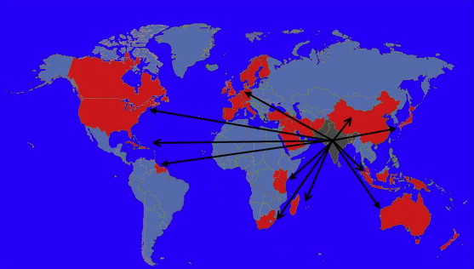
India is a country with a high migration rate over years. In the 1990s over 98 million people migrated from one place to another. It is the highest compared to any decade. Since 1951, the migrants during 1991-2001 have increased by 22%.
There are many reasons for the Indians to migrate to different places. One of the biggest reason to migrate is for employment. Nearly 14 million people migrated from their hometown to search for jobs. Most of these people were men. Women also migrate due to marriage. Although the migrants have the freedom to go to other places, the migrants have created pressure from working in the same market. They won’t gain much money from it.
These are the number of migrants per decade (in millions) :
1951-61 | = 66
1961-71 | = 68.2
1971-81 | = 81
1981-91 | = 80.9
1991-2001 | = 98.3

