The Lifestyle Of A *Takydromas Sexlineatus*

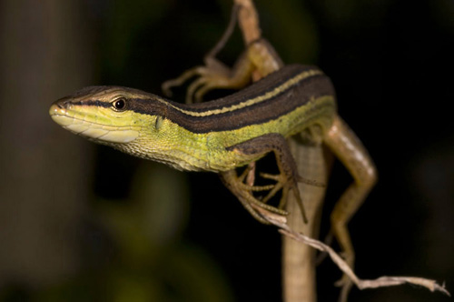

Science Lab Report

Aditya, Thomas, Josephine

8.1

**1. Research Question**

How does an artificial environment influence the lifestyle of *Takydromas Sexlineatus*?

**2. Objective**

The aim or the objective of this project is to design an artificial ecosystem for the lizard species *Takydromas Sexlineatus.* The artificial ecosystem should keep the lizard alive for 31 days. During the 31 days, observing the growth of the lizard on a daily basis is also required.

**3. Introduction**

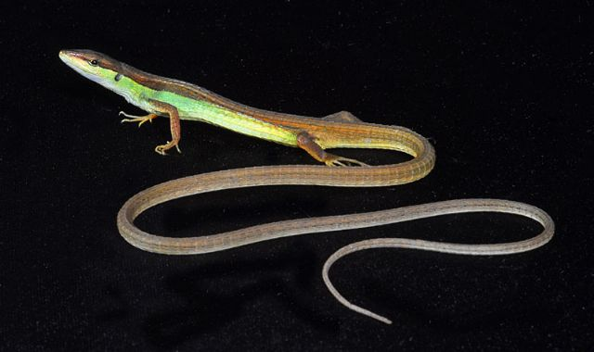The *Takydromas Sexlineatus* or better known as the long tailed lizards are known for their significantly long tail. These greenish brown to brown colored lizards grow up to 10-12 inches long, ¾ of their length is the tail which means that since the average body length of a healthy adult long tailed lizard is around 6cm, its tail could grow up to 30cm. Another reason why it’s called the long tailed lizard is because their tail is prehensile which means that they can use their tail to hang on objects.

These lizards are commonly found throughout Asia, especially in the Southeastern region. The long tailed lizards tend to live in bamboo forest or grassy regions which include house gardens. A garden was actually where the three *Takydromas Sexlineatus* were caught, the two larger ones were a male while the smaller one was a female. The difference between the male and female is on the sides of the lizard. Male have circular spots on the sides while female does not. The male also have a rather stronger color then the female, the female’s skin color is slightly paler.

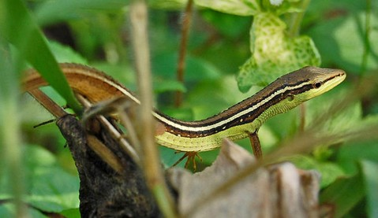Long tailed lizards spend most of their time on grass, where they will consume insects such as crickets, small arthropods and even grasshoppers. They are well adapted to a tropical habitat which means that they like it when it’s warm. At night they will crawl under long grasses or logs to keep their bodies warm. The long tailed lizards aren’t territorial, males and females will get along well when near to each other.

The physical factors that influence the lifestyle of long tailed lizards are temperature, light, water, oxygen and countless others. Since long tailed lizards have adapted well in tropical areas, the temperature during the day should be around 32-35 C while it could drop up to 18-21 C during the night. Although the long tailed lizards prefer the shade, light is also required in their lives. They need at 10 hours of light exposure on a daily basis which was why there were areas in our artificial ecosystem that were shady and areas that exposed the creatures to light. Water is also a essential requirement in the life of a long tailed lizard. Although the long tailed lizards tend to drink from rain drops on leaves or branches, cup filled with clean water is also essential inside the artificial ecosystem. The water should be shallow for it could result in a increase of humidity. The proper humidity level should be 70%-80%, having less water will help but misting the ecosystem with water should also be done. The oxygen inside the artificial ecosystem is also very essential, without oxygen the lizard will die. Eventhough photosynthesis will occur and supply oxygen for the lizards, holes on the lid are very important.

There are various biotic factors in the life of a *Takydromas Sexlineatus.* These lizards interact with various living organisms. The agile body along with the sharp claws and prehensile tail that the long tailed lizard owns improves their ability to escape and hunt. They are very fast in movement, their movements help them to get away from their enemies such as birds and snakes. However their natural abilities also help them to catch their prey which are insects such as grasshoppers and crickets. Grass and branches can also be included as a biotic factor for the long tailed lizard because they conceal their bodies on grass or branches in order to catch their prey. They would crawl slowly, undetected by their prey, when they are at range is when they rapidly assault their prey.

As long as both the physical and biotic factors are unharmed, the long tailed lizard will survive. Hence imitating the factors in their natural ecosystem into the artificial ecosystem will increase the survival of the lizards.

**4. Hypothesis**

Our group assumes that within the 31 days the three lizard will still remain in a healthy state because the living requirements of a *Takydromas Sexlineatus* have already been researched. The physical and biotic factors have already been found. By adjusting the temperature, feeding it with insects, supplying it with water and providing the lizards with the correct amount of light, they will survive.

**5a. Materials:**

1. Grasshoppers (5 per day)

2. Water (30mL per cup)

3. 1 Cricket

**5b. Tools**

1. Net Cage (25cm x 25cm x 30cm)

2. Glass Aquarium (30cm x 20cm x 25cm)

3. Plastic Cup

3. 1kg Sand

4. 10 Pebbles

5. 2 Branches

6. Leaves

7. Plastic Lid (30cm x 20cm x 25cm size which contains 10-15 holes)

8. 2 Twigs

9. Tape

**6. Procedure**

First Artificial Design

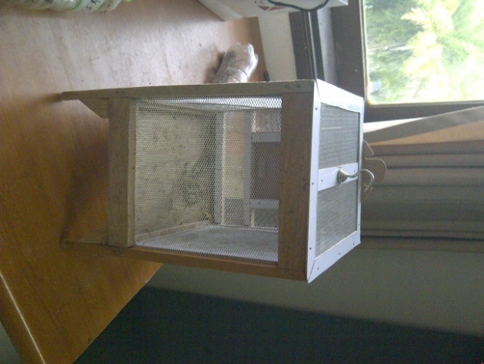1. Prepare the net cage and open the entrance of the cage.

2. Prepare the leaves, pebbles and twigs.

3. Place them inside the net cage.

4. Prepare the plastic cup, fill 30mL of water into it.

5. Place the plastic cup which is filled with water inside the cage.

6. Place the three lizards inside the cage and then close the entrance.

7. Prepare 5 grasshoppers and carefully put it inside the cage one by one.

1st Artificial Ecosystem Design

The cage needs to be moved from time to time for it is not a closed ecosystem. Temperature can change anytime especially if you are using an air conditioner

Entrance

Ligth will enter from the side of the net cage, the light will pass the net and reach the lizards. This light source can either be from the sun or the light bulb at our houses.

Since this is a net cage, oxygen will be able to flow just right through it. The plants inside could also produce oxygen from photosynthesis.

Twigs

Leaves which are placed every 3-4 days. The shady parts are under the leaves.

Pebbles

Water is found in the plastic cup.

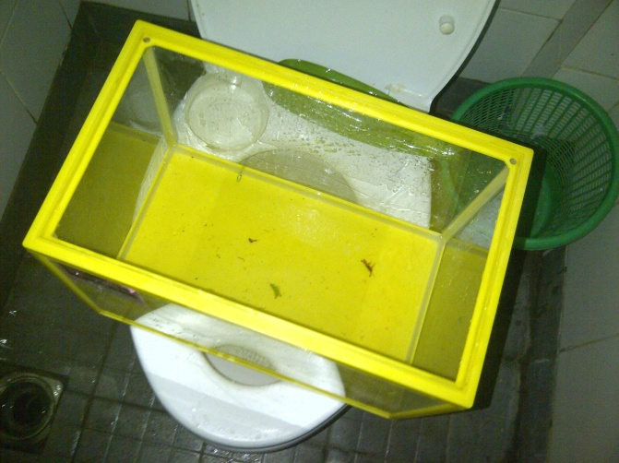Second Artificial Design

1. Prepare the glass aquarium.

2. Gradually fill the base with sand.

3. Prepare the leaves, pebbles and branches.

4. Place them inside the glass aquarium.

5. Prepare the plastic cup, fill 30mL of water into it.

6. Place the plastic cup which is filled with water inside the aquarium.

7. Prepare the plastic lid

9. Make 10-15 holes on it.

10. Put the plastic lid on the glass aquarium.

11. Carefully slide the three lizards into the glass aquarium, then the 5 grasshoppers and 1 cricket.

9. Tape the plastic lid to the glass aquarium.

2nd Artificial Ecosystem Design

The oxygen will flow through the holes created on the plastic lid. Oxygen will also be produced from the plants using photosynthesis.

Light will enter from the side of the aquarium, through the glass. The light source is either the sun or a light bulb.

Branches

The aquarium needs to be moved from time to time because a significant difference in temperature between the inside and outside of the aquarium will produce dew. Too much dew means high humidity which is not good for the lizard.

Water is found in the plastic cup.

Pebbles

Leaves which are replaced every 3-4 days. The shady parts are under the leaves.

Sand

3rd Artificial Design

1. Prepare the glass aquarium.

2. Prepare the leaves, pebbles and branches.

4. Place them inside the glass aquarium.

5. Prepare the plastic cup, fill 30mL of water into it.

6. Place the plastic cup which is filled with water inside the aquarium.

7. Prepare the plastic lid

8. Make 10-15 holes on it.

9. Put the plastic lid on the glass aquarium .

10. Carefully slide the three lizards into the glass aquarium, then the 5 grasshoppers.

11. Tape the plastic lid to the glass aquarium.

3rd Artificial Ecosystem Design

The oxygen will flow through the holes created on the plastic lid. Oxygen will also be produced from the plants using photosynthesis.

The ligth will enter from the side of the aquarium, through the glass. The light source is either the sun or a light bulb.

Water is found in the plastic cup.

Leaves which are replaced every 3-4 days. The shady parts are under the leaves.

Branches

Same with the second design, the aquarium needs to be moved from time to time because a significant difference in temperature between the inside and outside of the aquarium will produce dew. Too much dew means high humidity which is not good for the lizard.

Pebbles

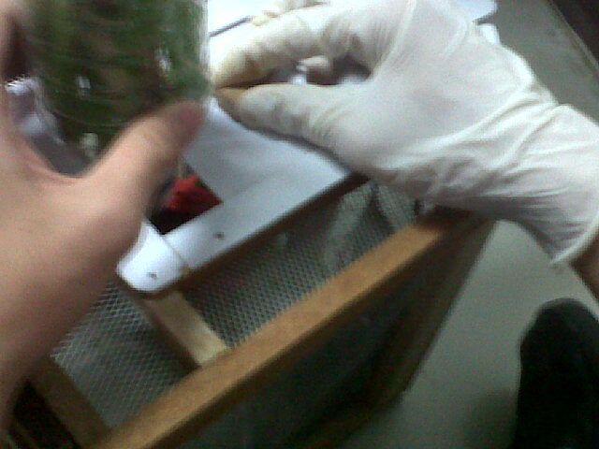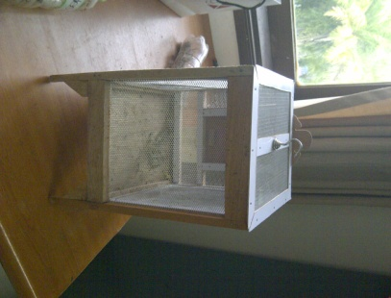**8. Result**

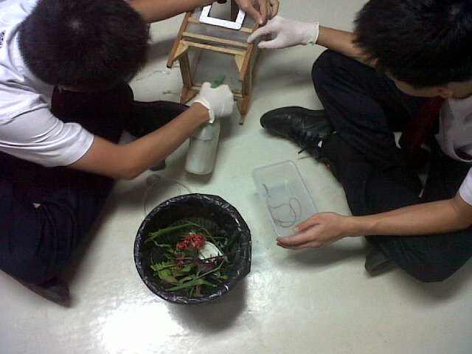

17/04/2012 – Feeding it with grasshoppers.

16/04/2012 – Putting the leaves, stones and water inside. After that we put the lizard.

16/04/2012 – The first artificial design, the net cage.

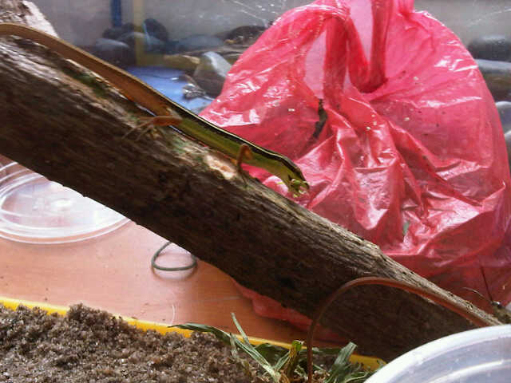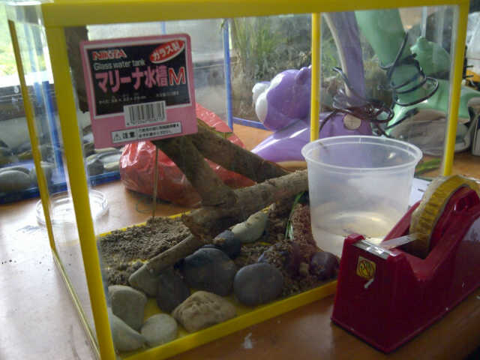

19/04/2012 – First time we saw the lizard eating a grasshopper in school.

19/04/2012 – The second artificial design, the glass aquarium. We filled it with pebbles, sand water, leaves and branches.

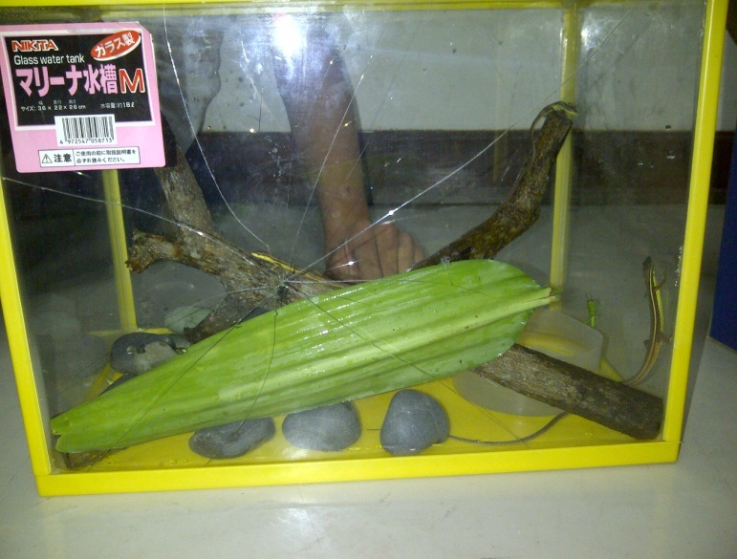

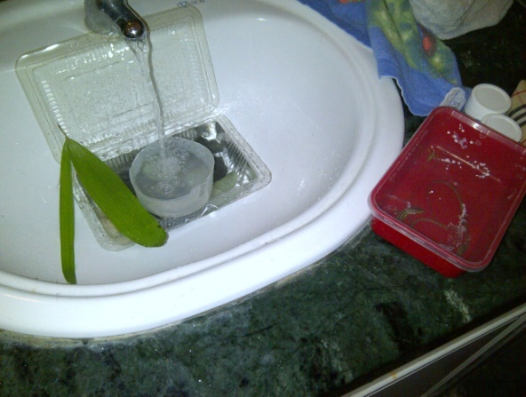

21/04/2012 – The cleaning process done by Aditya when he brought the lizard home during the weekend.

22/04/2012 – Artificial ecosystem design number three, we just took out the sand and relocated the branches. There was a accident when we set up the design which caused the crack.

C:\Users\Toshiba\Desktop\School\Gr.8\Quarter 4\Science\Photos\Kedunghalang-20120421-00159.jpg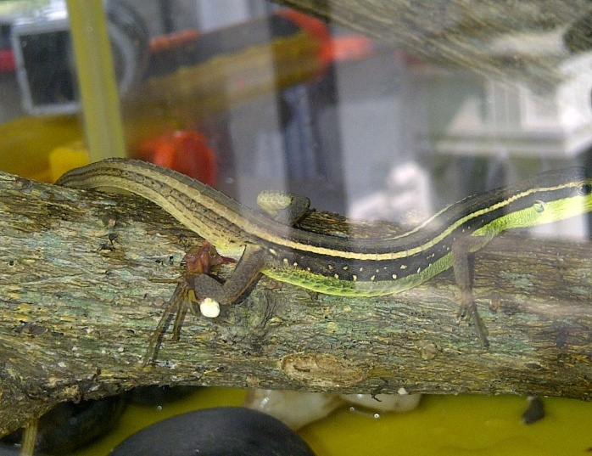

27/04/2012 – The smallest lizard got its prey, first bite didn’t kill the grasshopper. It took three bites for this little lizard.

22/04/2012 – The biggest lizard, it released its waste on the tree.

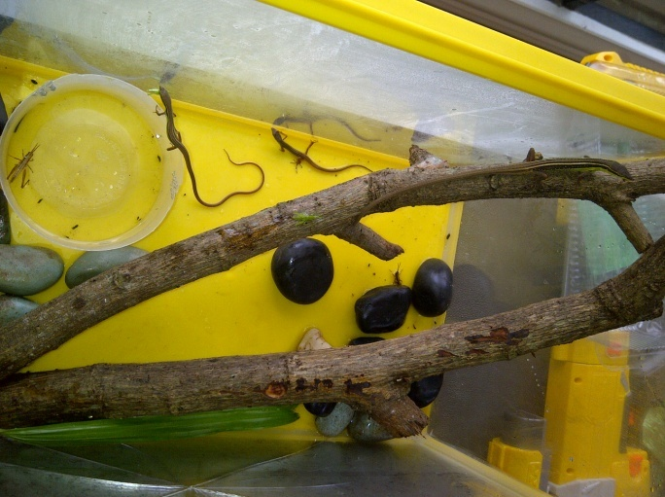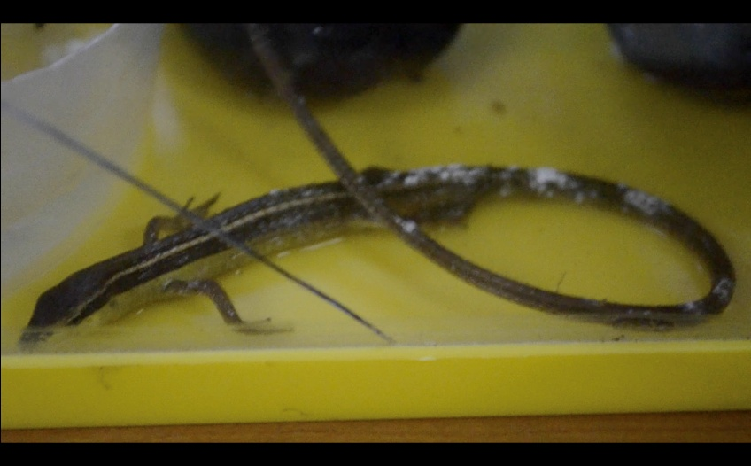

16/05//2012 – Eventhough this lizard is dead, we could see that it was shedding its skin. The white substance on the tail is prove of skin shedding.

02/05/2012 – The smallest lizard and the biggest lizard both bite the grasshopper, but the biggest lizard ate it.

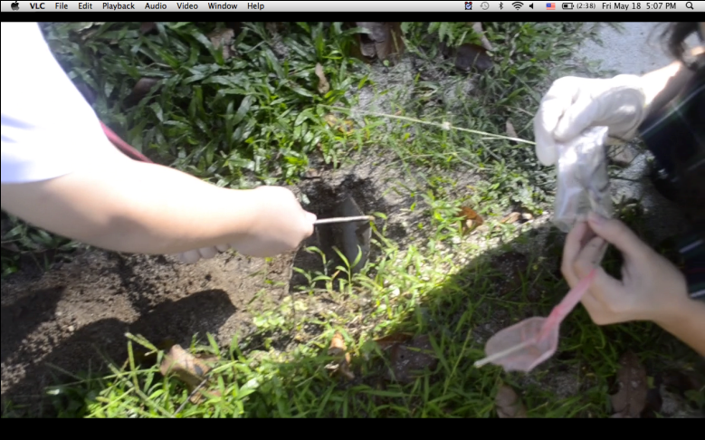

16/05//2012 – The biggest and the smallest lizard died and were buried. As for the third lizard, it escaped on the 9th of May.

**9. Discussion and Evaluation**

The goal of this project is to design a suitable artificial ecosystem for a long tailed lizard. To accomplish the goal, immitating the factors in the habitat of a long tailed lizard in our artificial ecosystem had to be done. Water, braches, leaves and pebble are all essential inside each artificial ecosystem design.

By analysing the pictures in the results, the lizards seem to have adapted in the artificial ecosystem because the lizard was able to catch its prey inside the glass aquarium. This indicates that the lizard thinks he is in his natural habitat. The reason in changing the net cage to a glass aquarium is because the net cage was just too small. Long tailed lizards are active which means that they need space. The glass aquarium provided much more space then the net cage because it was bigger, also the branches inside provided more movement for the lizard. The reason in taking out the sand in the third artificial ecosystem design is because the proper substance used for the base is pelleted. However pelleted isn’t commonly found which is the base has no substance on it.

When the second design was ready, grasshoppers weren’t the only food for the lizards. One cricket was let out inside the aquarium, however the cricket wasn’t eaten at all which was why crickets weren’t used anymore in their diet. The cricket probably wasn’t eaten because it was too big for the long tailed lizards.

In the glass aquarium, there were two organisms of different species living together for a period of time. This is called symbiosis. Eventhough most of the grasshoppers were eaten and got replaced, when the cricket was living among side with the lizards, both organisms weren’t harmed at all which meant that commensalism occured there. The predator/prey relationship definitely happened in all artificial ecosystem designs because that was how the lizard ate. As the predator, the lizard ate the prey which were the grasshoppers. Another environmental relationship which occured was competition. As seen on 2th May, two lizards were trying to eat one grasshopper. They both bit it at the same time however the bigger lizard got the grasshopper. This is considered competition because both lizards were fighting over the same resource which was food.

Towards the last part of the pictures in the result, the lizard’s skin was shedding. In the begining, the white substance on the tail wasn’t considered as skin shedding rather some sort of disease. After researching, there was no disease which includes white parts on the tail. Until a website which had pictures of long tailed lizards with white substances on their tails stated how it was actually skin shedding. Among the three lizards, only the biggest and smallest lizard were seen shedding skin, the other was escaped from the cage because its skin shed.

After evaluating the results, the reason to the death of the lizard was found. Before the lizard died, the aquarium wasn’t cleaned during the weekend which increased the humidity level. After the smallest one died, the aquarium was cleaned. However the aquarium wasn’t dried up which again increased the humidity level. When the humidity rises too much inside the aquarium, it created fungi on the branches. The branches were of course used by the lizards and it was the fungi that triggered the death of the lizards. The next two days the biggest lizard wasn’t able to survive in that condition and also died.

After we figured out the reason of the lizards death, the reason of such a drastic increase in the humidity level was very confusing. The reason for the high rise was probably because of the lid. The lid should have been a wire mesh or something that gas could flow through. A plastic lid wasn’t enough eventhough it had holes. Also the fact that the pebbles, leaves and branches were not dried up consistanly is a problem because more water increases the vapor and vapor cannot pass the plastic lid as easily as it can pass a wire mesh. This is probably something that needs to be thought of it the future because when evaporation does not happen freely, humidity occurs which slowly creates fungi.

**10. Conclusion**

In conclusion, our hypothesis is not true because all three lizards didn’t survive. Eventhough the biggest long tailed lizard died at the last day, it still indicates that we lack research when designing the artificial ecosystem. We should have realized that a wire mesh would be much more suitable then a plastic lid. We should have put in account about humidity, we didn’t realize that humidity had a huge role in a ecosystem until our lizards died. If we were to have a project similar as to this one, we would definitely use a wire mesh instead of a plastic lid. We would also dry of the stones, branches and leaves to prevent humidity. Eventhough we have failed to create a perfect artificial ecosystem for the lizards, we have learned something new. Therefore this project wasn’t useless at all.

**11. Reference**

*Google Images*. Web. 18 May 2012. <http://www.generalexotics.com/images/Longtail_Grass_Lizard.jpg>.

*Google Images*. Web. 18 May 2012. <http://www.petwatch.net/writable/pet_report_photos/photo/480x/grass-lizard-crop.jpg>.

Attachment

*Google Images*. Web. 16 May 2012. <http://www.sandfiredragonranch.com/images/Longtail%20Grass%20Lizard.jpg>.

"How to Care for a Long Tail Lizard." *EHow*. Demand Media, 31 May 2007. Web. 16 May 2012. <http://www.ehow.com/how_2044747_care-long-tail-lizard.html>.

Johnson, Priya. "Long-tailed Lizard." *Buzzle.com*. Buzzle.com, 09 Apr. 2010. Web. 17 May 2012. <http://www.buzzle.com/articles/long-tailed-lizard.html>.

*Long Tailed Grass Lizard*. PETCO Animal Supplies Inc, 2004. Web. 17 May 2012. <http://www.petco.com/caresheets/lizards/Lizard_LongTailedGrass.pdf>.

Mcleod, Lianne. "Care of Long TailedÂ Lizards." *About.com Exotic Pets*. Web. 15 May 2012. <http://exoticpets.about.com/od/lizardsaspets/p/longtailliz.htm>.